Lymphoma reporting and staging :

Report:

*To document size of the nodes and masses use Lugano classifications*:

Target lesions: measure at least 6 lesions- these should represent the largest possible number og anatomical sites, with preference for the – (a) Largest lesions (b) mediastinal lesions (c) retroperitoneal lesions. Target lesions are those node or nodal masses LDi > 15 mm or extra nodal lesions > 10 mm. Present BIdmensional diameters for calculating PPD (product of perpendicular diameter) and SPD (sum of product of perpendicular diameter). Use table in excel file stored at following location-:

|  |  |  |  |  |  |  |
| --- | --- | --- | --- | --- | --- | --- |
| Target lesions | | | | | | |
| S.No | Site | Above diaphragm | Series/Slice | Size (Tr) | Size(AP) | PPD |
| 1 |  | Yes |  |  |  | 0 |
| 2 |  | No |  |  |  | 0 |
| 3 |  |  |  |  |  | 0 |
| 4 |  |  |  |  |  | 0 |
| 5 |  |  |  |  |  | 0 |
| 6 |  |  |  |  |  | 0 |
| SPD |  |  |  |  |  | 0 |
|  |  |  |  |  |  |  |
|  |  |  |  |  |  |  |
| Non Target lesions | | | | | | |
| S.No | Site | Series/Slice | Size(only for spleen) |  |  |  |
| 1 | Spleen |  | Vertical=  Tr X Perp= |  |  |  |
| 2 |  |  |  |  |  |  |
| 3 |  |  |  |  |  |  |
| 4 |  |  |  |  |  |  |
| 5 |  |  |  |  |  |  |
| 6 |  |  |  |  |  |  |

Conclusion:

Staging:

*If the HPE diagnosis reveals Lymphoma the staging will be as follows-:*

**Modified Ann Arbor staging**-:

Stage I -: (Single nodal group involvement seen)

Stage IE -: (Single extranodal involvement).

Stage II- : (>=2 nodal groups involved on same side of diaphragm)

Stage IIE-: (Single nodal group involved + contagious extranodal involvement)

Stage II E-: (>= two nodal group involved + contagious extranodal involvement)

Stage II (Bulky): (>= 2 nodal group with bulky nodes - that is at least one nodal mass > 10 cm or nodal measuring > 1/3 of transthoracic diameter)

***----Advanced stages----***

Stage III- : (Nodes on both sides of diaphragm involved)

Stage III-: (Nodes above diaphragm involved + Spleen involved)

Stage IV: (Nodal involvement with non contagious extra nodal involvement)

Note: If HPE reveals Hodgkins Lymphoma, the stage needs to be subdivided into Category A (absent of systemic symptoms) v/s Category B ( presence of systemic symptoms--: > 10 % weight loss or Night sweats or Fever). (not applicable for NHL).

To assess response to treatment in Lympoma use Lugano classification-:

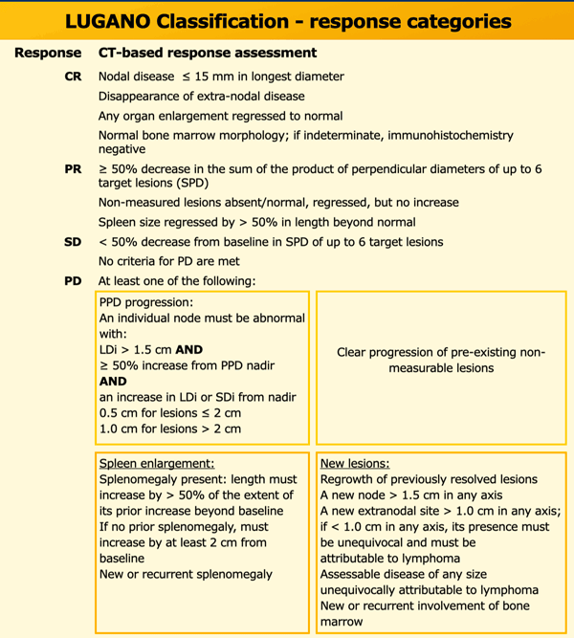

For assessing response to treatment for Lymphoma patient in Immunomodualtion use LYRIC (**Lymphoma Response to Immunomodulatory Therapy Criteria**). This is modification of above described Lugano classification with and added category of indeterminate response (IR).

**Indeterminate response (IR)**

* **IR(1): ≥ 50% increase in overall tumor burden (sum of the product of the perpendicular diameters (SPD) of up to six target measurable nodes and extranodal sites) occurred in the first 12 weeks of therapy and without clinical deterioration**
* **IR(2): new lesions or ≥ 50% increase of existing lesion(s) without a ≥ 50% increase of overall tumor burden at any time during treatment.**
* **IR(3): increased**[**FDG**](https://radiopaedia.org/articles/positron-emission-tomography?lang=us)**uptake of one or more lesions without any increase in size or number of those lesions.**

**If two patterns of IR are present at the same time, priority should be given to IR(1) or (2) over IR(3).**

**After an IR, a biopsy or subsequent imaging within 12 weeks is recommended to confirm true progressive disease versus a flare or pseudoprogression.**